Rosanna Cubs
– Swimming night
WaterMarc Greensborough
Tuesday 26th March, 6:15pm-8pm

This week, we’ll be going swimming (and some sliding) at WaterMarc in Greensborough. This will be a fun night rather than a badge night – Cubs will have a swimming night later in the year for Swimming Badges.

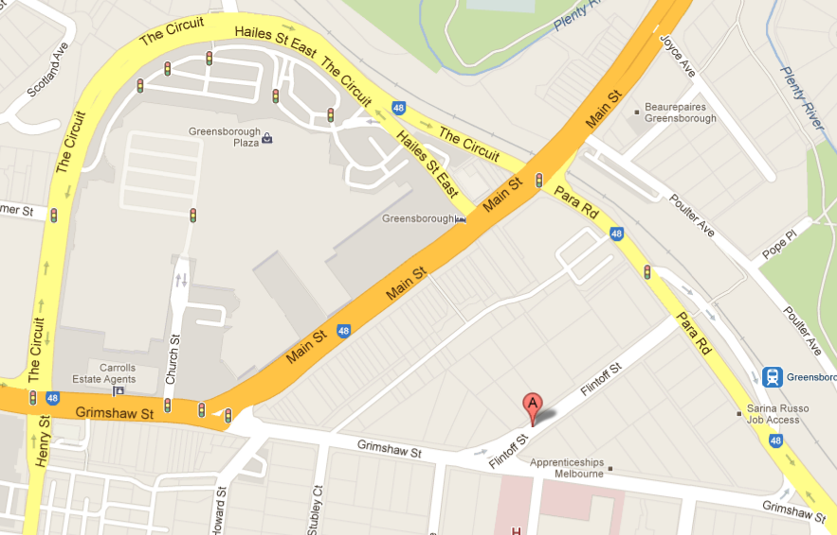
- Time: 6:15-8pm – Note different time
to normal Cubs. Pool is open later
for families who choose to stay on. (Please be on time so we can get kids in and on the slides ASAP)
- Cost:
  - Swim & Waterslides $15.00
  - Swim only $6.60
  - Adults $8.80 (& slide = $20.20)
  - Adult Concession $7.00 / $16.20
  - Entry only (no swim/slide) $0

PLEASE BRING CORRECT MONEY AMOUNT

- Slides open until 7:00pm only – given the short time on the slides, parents/Cubs need to decide whether it’s worth paying the extra $8.40 to do it.
- There are height rules for the Waterslides:
  - Taller than 122cm = can go on all slides
  - 107cm<122cm = can go on Pipeline
  - Shorter than 107cm = can’t go on waterslides
…..To save time, please know your Cub(s)’ height and bring the appropriate/exact money as per ‘Cost’ above.

- Location: MEET IN THE FOYER at WaterMarc Aquatic Centre –
1 Flintoff St, Greensborough
- Bring: Togs, Towel, EXACT money for your entry, & warm clothes to go home in, plus swim goggles, snacks/drink bottle if you want them.

Don’t miss out – see you there!

Regards

The Leaders
Rosanna Cub Scouts
See Rosanna Cubs at http://www.rosannacubs.org

